VISUALIZATION TOOL FOR ELECTRIC VEHICLE CHARGE AND RANGE ANALYSIS-UPDATED

MENTOR NAME – SRI L LAKSHMI NARAYANA

TEAM ID: LTVIP2025TMID52604

TEAM LEADER

NAME - G.SAI RAGHAVA

MAIL - [sai052500@gmail.com](mailto:sai052500@gmail.com)

ID NO: SBAP0052604

ROLL NO:233888102014

TEAM MEMBER



NAME – B. SIVA LOKESH

MAIL – [lsiva7231@gmail.com](mailto:lsiva7231@gmail.com)

ID NO: SBAP0052587

ROLL NO:23388810200



NAME – D DINESH

MAIL – [dandedinesh7242@gmail.com](mailto:dandedinesh7242@gmail.com)

ID NO – SBAP0052610

ROLL NO:233888102011



NAME – KADAVA TEJA

MAIL – [tejakadava687@gmail.com](mailto:tejakadava687@gmail.com)

ID NO:SBAP0052580

ROLL NO:233888102019



NAME – KRISHNA AJAY H

MAIL – [krishnaajay8384@gmail.com](mailto:krishnaajay8384@gmail.com)

ID NO: SBAP0052576

ROLL NO:233888102028

TEAM GROUP PHOTO



**Vehicle Charge and Range Visualization Tool for Electric Analysis**

The Electric Vehicle (EV) is not new, but it has been receiving significantly more attention in recent years. Advances in both EV analytics and battery technologies have led to increased automotive market share. However, this growth is not attributed to hardware alone. The modern mechatronic vehicle marries electrical storage and propulsion systems with electronic sensors, controls, and actuators, integrated closely with software, secure data transfer, and data analysis, to form a comprehensive transportation solution. Advances in all these areas have contributed to the overall rise of EV’s, but the common thread that runs through all these elements is data analytics.

**Problem Statement:**

Analysing different data from Multiple sources for Electric cars in India and Globally. We have 4 Different datasets we need to analyse the data and create Dashboard and story that can represent the data and show the Visuals for the data.

Technical Architecture:

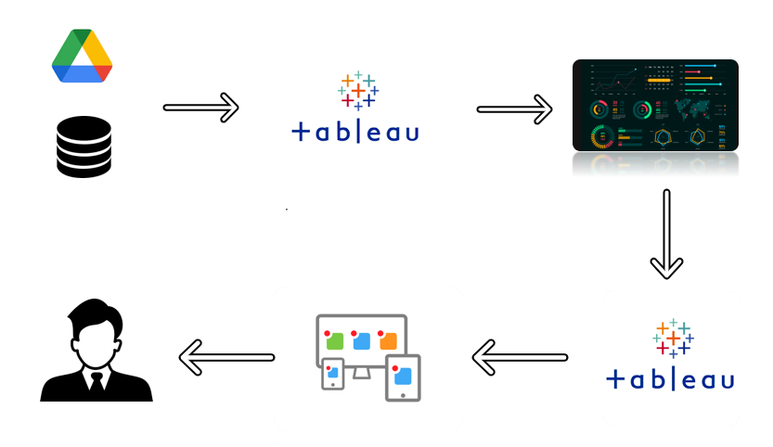

**Pre requisites**

For Completing this project these are some of the prerequisites needed

* A system with a minimum 4GB RAM and 128GB Hard Disk
* Good Internet Connection
* Google Drive / Any of the Database Server with Management Studio
* MySQL:
* <https://youtu.be/2c2fUOgZMmY>
* **SQL Server Management Studio:**
* <https://youtu.be/kGdTg-vGs-E>
* **Tableau Desktop:**
* https://youtu.be/b3pWYyrHQo8
* Tableau Public Account: <https://public.tableau.com/app/discover>
* Html, CSS or Bootstrap

**Prior Knowledge**

To Complete this project, one must understand the below conceptsand able to work with the tools

**Data Visualization:**

* <https://youtu.be/5gpnZvMSTZs>
* **Uni-Variate, Bi- Variate and Multi-Variate Analysis:**
* <https://youtu.be/JG8GRlMjp3c>
* **Chart Types:**
* <https://youtu.be/csXmVBw8cdo>
* **Tableau:**
* <https://youtu.be/aHaOIvR00So>
* **Business Intelligence:**
* <https://youtu.be/Hg8zBJ1DhLQ>

**Project Objectives**

By the end of this project, you will:

* Able to Connect Tableau with different data sources
* Know fundamental concepts and techniques used for Data Visualization.
* Gain a broad understanding about data and different types of charts.
* Have knowledge on developing Visualizations, Dashboards and Story.
* Able to Integrate the developed dashboard and story with the web application

**Project Flow**

To accomplish this, we have to complete all the activities listed below,

* Data collection
  + Collect the dataset or create the dataset
* Database /Spreadsheet Connection
  + Understand the dataset
  + Import Dataset into the database
  + Connect Tableau Desktop to Database server.
* Visualizing and analysing data
* Understand the Data and the Business Questions
* Based on the Business questions develop the different visualizations
* Dashboard
  + Develop the Dashboard
* Story
  + Develop the Storyboard
* Publishing to the Tableau Public & Web Application Integration
  + Developed Visualizations, Dashboard and story will be published to Tableau Public Account.
  + Once it is published, we will get the shareable links
  + Develop a web application using HTML, CSS or Using Bootstrap
  + Integrate the Visualizations, Dashboard and Story with the Web Application

**Data Collection**

Data collection is the process of gathering and measuring information on variables of interest, in an established systematic fashion that enables one to answer stated research questions, test hypotheses, and evaluate outcomes and generate insights from the data.

**Downloading the dataset**

Please use the link to download the dataset:

<https://drive.google.com/drive/folders/1Rkzdks6Us1Uq2SRB4nxMAb83jN5bpHll>

**Working with Dataset**

Here we will start working and understanding the dataset

**Understand the data**

Data contains all the meta information regarding the columns described in the CSV files. we have provided 4 CSV files:

1. EVIndia

2. Electric_vehicle_charging_station_list

3. ElectricCarData_Clean

4. Cheapestelectriccars-EVDatabase

**Column Description for EVIndia:**

• Car - Car Brand name and model

• Style Range - Style range of car

• Transmission- Transmission type

• VehicleType – Type of vehicle

• PriceRange(Lakhs) - Price Range in Lakhs

• Capacity - Capacity of car

• BootSpace – Boot space of the car

• BaseModel – Base model name

• TopModel – Top model name

**Column Description for Electric_vehicle_charging_station_list:**

• region: This column represents the region of the charging station.

• address: This column represents the address of the charging station.

• aux address: This column represents the auxiliary address of the charging station.

• latitude: This column represents the latitude of the charging station.

• longitude: This column represents the longitude of the charging station

• type: This column represents the type of the charging station.

• power: This column represents the power of the charging station.

• service: This column represents the type of service at the charging station.

**Column Description for ElectricCarData_Clean:**

• Brand

• Model

• AccelSec

• TopSpeed_KmH

• Range_Km

• Efficiency_WhKm

• FastCharge_KmH

• RapidCharge

• PowerTrain

• PlugType

• BodyStyle

• Segment

• Seats

• PriceEuro

**Column Description for Cheapestelectriccars-EVDatabase:**

• Name

• Subtitle

• Acceleration

• TopSpeed

• Range

• Efficiency

• FastChargeSpeed

• Drive

• NumberofSeats

• PriceinGermany

• PriceinUK

**Import Dataset into Database**

Explanation video link: [Database creation](https://drive.google.com/file/d/1ScrARvxjMjbBVgrbdT-EnCIjNTTwLeGI/view?usp=share_link)

Explanation video link: [Basic SQL Operations](https://drive.google.com/file/d/1SkrfVWscOTLv9eqMcpD3lt7bS3sGKBPH/view?usp=share_link)

**Connect Tableau Desktop to Database server**

Explanation video link: [Link](https://drive.google.com/file/d/1nyRJyGwCF7dsA2Q4XgK_LZn9jirw7PXn/view?usp=share_link)

**Data Preparation**

Preparing the data for visualization involves cleaning the data to remove irrelevant or missing data, transforming the data into a format that can be easily visualized, exploring the data to identify patterns and trends, filtering the data to focus on specific subsets of data, preparing the data for visualization software, and ensuring the data is accurate and complete. This process helps to make the data easily understandable and ready for creating visualizations to gain insights into the performance and efficiency.

Link:<https://drive.google.com/file/d/1lAMzG-Cut2uKqrYv7Z1gHtBJZ7XtM1YT/view?usp=share_link>**Data Visualization**

Data visualization is the process of creating graphical representations of data in order to help people understand and explore the information. Data visualisation aims to make complex data sets more accessible, intuitive, and easier to interpret. By using visual elements such as charts, graphs, and maps, data visualizations can help people quickly identify patterns, trends, and outliers in the data.

**Charging Stations by region and type in India**

Explanation video link: <https://drive.google.com/file/d/1QuWuNC6S0wd04n8kCH_Z7Bo9PnZZvaEK/view?usp=share_link>

**EV Charging stations map of India**

Explanation video link: <https://drive.google.com/file/d/1JgMlZ7pKEIoYvOe5X0v59kmVTFZ-nSQV/view?usp=share_link>

**Different EV cars in India**

Explanation video link: <https://drive.google.com/file/d/1PvVm2oqr8j1ERO2IuaNUcsROI3QY2ffC/view?usp=share_link>

**Top speed for different Brands**

Explanation video link: <https://drive.google.com/file/d/1VXW8C9b4ycVHaEXnAJoBgB_N_miSIl9V/view?usp=share_link>

**Price for different cars in India**

Explanation video link: <https://drive.google.com/file/d/115HwkYlphwVgQGu8LHxBmuJJKH9dyfhp/view?usp=share_link>

**Top 10 most efficient EV Brands**

Explanation video link: <https://drive.google.com/file/d/1EhhapHlPsEqEE21e__2sLHQtR0VDXt8d/view?usp=share_link>

**Brands according to Bodystyle**

Explanation video link: <https://drive.google.com/file/d/16KiZpHu-mIdDb88ggZ8ZzvrOqpAJw8gg/view?usp=share_link>

**Brand filtered by PowerTrain type**

Explanation video link: <https://drive.google.com/file/d/1Gnrj7h6A7il6p26TLTNfRVQTYnREoQwn/view?usp=share_link>

**No of models by each brand**

Explanation video link: <https://drive.google.com/file/d/1-FZplgBanEa6HHql9M-Iu6YchyQszskC/view?usp=share_link>

**Summary card for Different brands of EV Cars globally**

Explanation video link:<https://drive.google.com/file/d/1CaL3ZLOypWlH77xmabJg4K8fKNlxaVtH/view?usp=share_link>

**Summary card for Different brands of EV Cars in India**

Explanation video link: <https://drive.google.com/file/d/1C61Jxi4jOCdoVbrRNWluDSJse6dguMPS/view?usp=share_link>**Dashboard**

A dashboard is a graphical user interface (GUI) that displays information and data in an organized, easy-to-read format. Dashboards are often used to provide real-time monitoring and analysis of data, and are typically designed for a specific purpose or use case. Dashboards can be used in a variety of settings, such as business, finance, manufacturing, healthcare, and many other industries. They can be used to track key performance indicators (KPIs), monitor performance metrics, and display data in the form of charts, graphs, and tables.

**Creating the Dashboard**

Once you have created views on different sheets in Tableau, you can pull them into a dashboard.

Explanation video link: [Link](https://drive.google.com/file/d/1R-WWO932vyqfBuGuhQsFLyfAlbbf6p_8/view?usp=share_link)

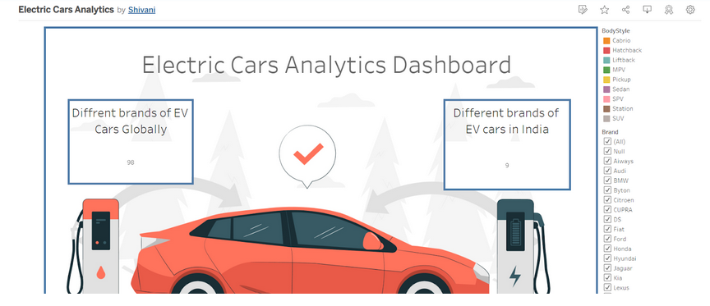

**Story**

A data story is a way of presenting data and analysis in a narrative format, with the goal of making the information more engaging and easier to understand. A data story typically includes a clear introduction that sets the stage and explains the context for the data, a body that presents the data and analysis in a logical and systematic way, and a conclusion that summarizes the key findings and highlights their implications. Data stories can be told using a variety of mediums, such as reports, presentations, interactive visualizations, and videos.

**Creating the story board**

Explanation video link:  [Link](https://drive.google.com/file/d/1BIm4nlyGNqrclyIN-PZ27-g0VUIVptCN/view?usp=share_link)

**Publishing and Web integration**

Publishing helps us to track and monitor key performance metrics, and to communicate results and progress. help a publisher stay informed, make better decisions, and communicate their performance to others.

**Publishing dashboard and reports to tableau public**

Step 1: Go to Dashboard/story, click on the share button on the top ribbo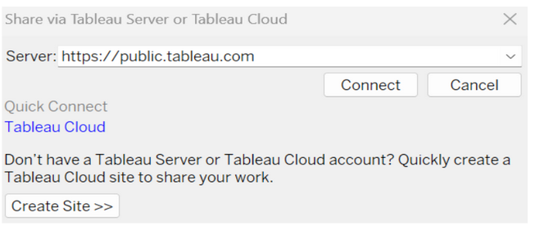

 Give the server address of your tableau public account and click on connect.

Explanation Video:-   [Link](https://drive.google.com/file/d/1HU4uV8P8Hc53eu0XxYHPRlu51YFK-8NA/view?usp=share_link)

step 2: Once you click on connect it will ask you for tableau public user name and password

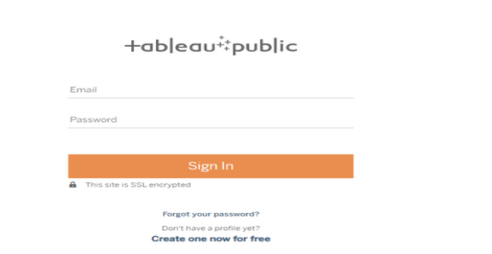

Once you login into your tableau public using the credentials, the particular visualization will be published into tableau public

Note: While publish the visualization to the public, respective sheet will get published where you click on share option

**Embed Dashboard & Story with Web Bootstrap**

Explanation video link:  [Link](https://drive.google.com/file/d/1FPCcu6LgfCjSD466aE7xYxC3BfViZEOm/view?usp=share_link)

Clean Data from Excel, CSV, PDF, and Google Sheets with Data Interpreter

*Applies to: Tableau Cloud, Tableau Desktop, Tableau Server*

When you track data in Excel spreadsheets, you create them with the human interface in mind. To make your spreadsheets easy to read, you might include things like titles, stacked headers, notes, maybe empty rows and columns to add white space, and you probably have multiple tabs of data too.

When you want to analyze this data in Tableau, these aesthetically pleasing attributes make it very difficult for Tableau to interpret your data. That’s where Data Interpreter can help.

**Tip:** Though Tableau's Excel add-in is no longer supported, Data Interpreter can help you reshape your data for analysis in Tableau.

What does Data Interpreter do?

Data Interpreter can give you a head start when cleaning your data. It can detect things like titles, notes, footers, empty cells, and so on and bypass them to identify the actual fields and values in your data set.

It can even detect additional tables and sub-tables so that you can work with a subset of your data independently of the other data.

After Data Interpreter has done its magic, you can check its work to make sure it captured the data that you wanted and identified it correctly. Then, you can make any necessary adjustments.

After you select the data that you want to work with, you might also need to do some additional cleaning steps like pivoting your data, splitting fields, or adding filters to get the data in the shape you want before starting your analysis.

**Note**: If your data needs more cleaning than what Data Interpreter can help you with, try [Tableau Prep(Link opens in a new window)](https://www.tableau.com/products/prep).

Turn on Data Interpreter and review results

1. From the **Connect** pane, connect to an Excel spreadsheet or other connector that supports Data Interpreter such as Text (.csv) files, PDF files or Google sheets.
2. Drag a table to the canvas (if needed), then on the **Data Source** page, in the left pane, select the **Use Data Interpreter** check box to see if Data Interpreter can help clean up your data.

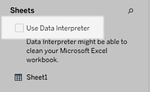

**Note:** When you clean your data with Data Interpreter, Data Interpreter cleans all the data associated with a connection in the data source. Data Interpreter does not change the underlying data.

1. In the Data pane, click the **Review the results** link to review the results of the Data Interpreter.

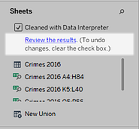

A copy of your data source opens in Excel on the **Key for the Data Interpreter** tab. Review the key to find out how to read the results.

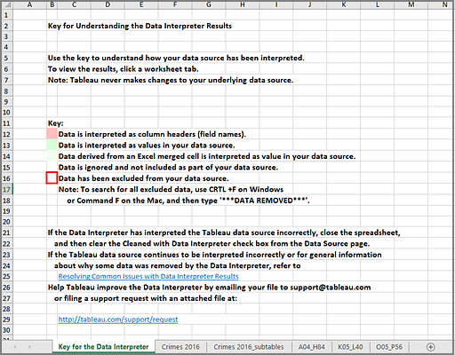

1. Click each tab to review how Data Interpreter interpreted the data source.

If Data Interpreter found additional tables, also called found tables or sub-tables, they are identified in the <sheet name>_subtables tab by outlining their cell ranges. A separate tab is also included for each sub-table, color coded to identify the header and data rows.

If Data Interpreter does not provide the expected results, clear the **Cleaned with Data Interpreter** check box to use the original data source.

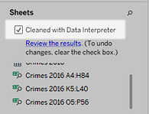

1. To replace the current table with any of the found tables, drag the current table off the canvas and then drag the found table that you want to use to the canvas.

If Data interpreter has misidentified the range of the found table, after you drag the found table to the canvas, click the drop-down arrow on that table, and then select **Edit Found Table** to adjust the corners of the found table (the top-left cell and bottom-right cell of the table).

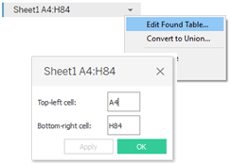

1. After you have the data that you want to work with, you can apply any additional cleaning operations to your data so that you can analyze it.

Data Interpreter Example

In this example we are connecting to an Excel spreadsheet with violent crime data by city and state for the year 2016. This spreadsheet includes multiple tables on one sheet and some extra formatting.

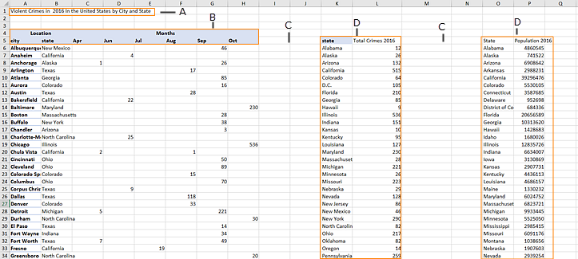

1. Title
2. Merged header cells
3. Extra white space
4. Sub-tables

The extra formatting in this spreadsheet makes it difficult for Tableau to determine what the field headers and values are.

Instead, it reads the data vertically and assigns each column the default value F1, F2, F3 (Field 1, Field 2, Field 3) and so on. Blank cells are read as null values.

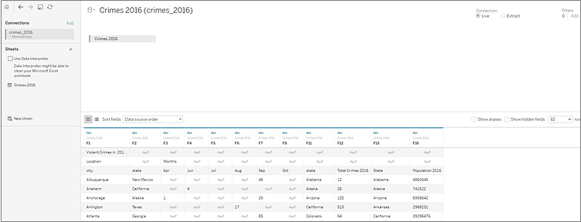

To see if Data Interpreter can help clean this data set, we select **Use Data Interpreter**.

Data Interpreter detected the proper headings for the fields, removed the extra formatting and found several sub-tables. The sub-tables are listed in the **Sheets** section in the Data pane and are named using the original sheet name and the cell ranges for each sub-table.

In this example there are three sub-tables: **Crimes 2016 A4:H84**, **Crimes 2016 K5:L40**, and **Crimes 2016 O5:P56**.

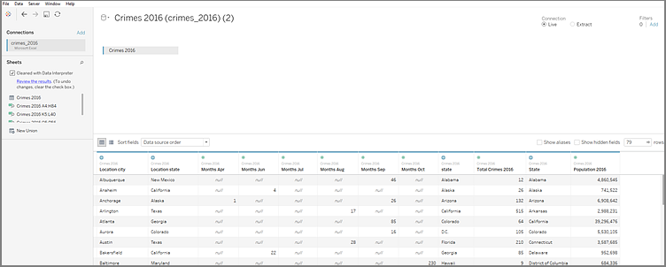

To examine the results of the Data Interpreter more closely, we click the **Review the results** link in the Data pane to view an annotated copy of the spreadsheet.

Here we see a copy of the original data, color coded to identify which data was identified as header data and which data was identified as field values.

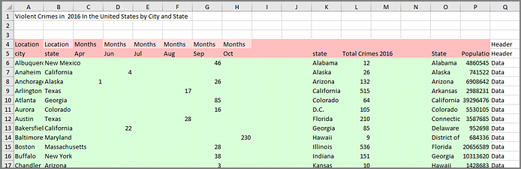

The next tab shows us the sub-tables that Data Interpreter found, outlined by the cell ranges.

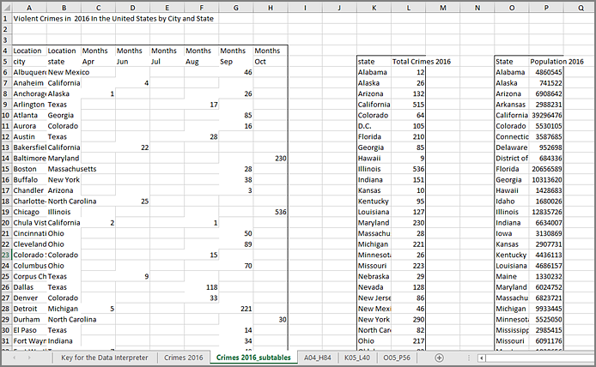

In this example the first sub-table, **Crimes 2016 A4:H84**, has the main data that we want to work with. To use this table as our data table, we can simply drag the original table off the canvas and then drag the new table to the canvas.

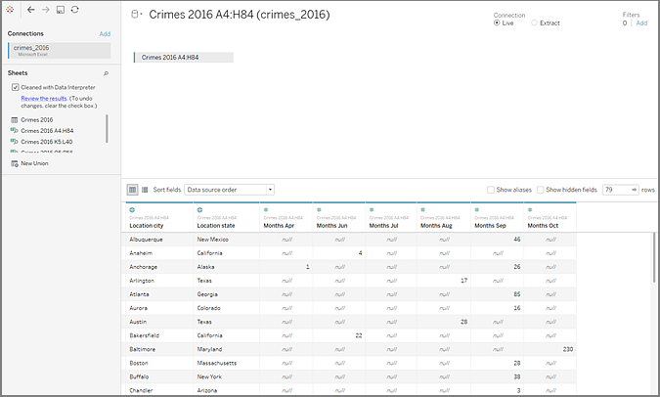

Once we have the data that we want to work with in the canvas, we can do some additional clean up on the data. For example we can:

* Change the field names so that they represent city, state, and month names.
* Pivot the months fields.
* Drag in the third sub-table **Crimes 2016 o5:P56** and join it to our first sub-table on the **State** field to include state populations for our analysis.
* Hide any duplicate fields that were added as a result of the join.

The results might look something like this:

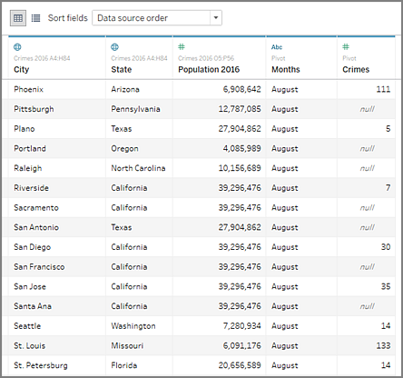

Now we are ready to start analyzing our data in Tableau.

When Data Interpreter is not available

The Data Interpreter option might not be available for the following reasons:

* **The data source is already in a format that Tableau can interpret:** If Tableau Desktop doesn't need extra help from Data Interpreter to handle unique formatting or extraneous information, the Data Interpreter option is not available.
* **Many rows or many columns:** The Data Interpreter option is not be available when your data has the following attributes:
  + Data contains more than 2000 columns.
  + Data contains more than 3000 rows and more than 150 columns.
* **The data source is not supported:** Data Interpreter is only available for Microsoft Excel, Text (.csv) files, PDF files and Google Sheets. For Excel, your data must be in the .xls or .xlsx format.